**Lab 3: User library for GPIO control**

David Garcia Torre

* Table with data types,

|  |  |  |  |
| --- | --- | --- | --- |
| Data type | Number of bits | Range | Description |
| uint8_t | 8 | 0, 1, ..., 255 | Unsigned 8-bit integer |
| int8_t | 8 | -128…127 | Signed 8-bit integer |
| uint16_t | 16 | 0…65535 | Unsigned 16-bit integer |
| int16_t | 16 | -32768…32767 | Signed 16-bit integer |
| float | 32 | -3.4e+38, ..., 3.4e+38 | Single-precision floating-point |
| void | 64/128/256 | 2^128 − 1 | Single-precision floating-point |

* Completed source code from the example.

/*

* lab3.c

* Author : TheGT23

*/

#include <avr/io.h>

// Function declaration (prototype)

*uint16_t* calculate(*uint8_t* x, *uint8_t* y) ;

int main(void)

{

*uint8_t* a = 156;

*uint8_t* b = 14;

*uint16_t* c;

// Function call

c = calculate (a, b);

while (1)

{

}

return 0;

}

// Function definition (body)

*uint16_t* calculate(*uint8_t* x, *uint8_t* y)

{

*uint16_t* result; // result = x^2 + 2xy + y^2

result = x*x + 2*x*y + y*y;

return result;

}

Listing of library source file gpio.c

/***********************************************************************

*

* GPIO library for AVR-GCC.

* ATmega328P (Arduino Uno), 16 MHz, AVR 8-bit Toolchain 3.6.2

*

* Copyright (c) 2019-2020 Tomas Fryza

* Dept. of Radio Electronics, Brno University of Technology, Czechia

* This work is licensed under the terms of the MIT license.

*

**********************************************************************/

/* Includes ----------------------------------------------------------*/

#include "gpio.h"

/* Function definitions ----------------------------------------------*/

void GPIO_config_output(volatile *uint8_t* *reg_name, *uint8_t* pin_num)

{

*reg_name = *reg_name | (1<<pin_num); //Set bit (or¡)

}

/*--------------------------------------------------------------------*/

void GPIO_config_input_nopull (volatile *uint8_t* *reg_name, *uint8_t* pin_num)

{

*reg_name = *reg_name & ~(1<<pin_num); // Data Direction Register

*reg_name++; // Change pointer to Data Register

*reg_name = *reg_name & ~ (1<<pin_num); // Data Register

}

/*--------------------------------------------------------------------*/

void GPIO_config_input_pullup(volatile *uint8_t* *reg_name, *uint8_t* pin_num)

{

*reg_name = *reg_name & ~(1<<pin_num); // Data Direction Register

*reg_name++; // Change pointer to Data Register

*reg_name = *reg_name | (1<<pin_num); // Data Register

}

/*--------------------------------------------------------------------*/

void GPIO_write_low(volatile *uint8_t* *reg_name, *uint8_t* pin_num)

{

*reg_name = *reg_name & ~(1<<pin_num); //Clear bit(and not)

}

/*--------------------------------------------------------------------*/

void GPIO_write_high(volatile *uint8_t* *reg_name, *uint8_t* pin_num)

{

*reg_name = *reg_name | (1<<pin_num); //Set bit(or)

}

/*--------------------------------------------------------------------*/

void GPIO_toggle(volatile *uint8_t* *reg_name, *uint8_t* pin_num)

{

*reg_name = *reg_name ^ (1<<pin_num); //Toggle the bit

}

/*--------------------------------------------------------------------*/

*uint8_t* GPIO_read(volatile *uint8_t* *reg_name, *uint8_t* pin_num)

{

*uint8_t* result = 0;

if(bit_is_clear(*reg_name,pin_num)){ // if 'PUSH' (0) -> I enter de 'if'

result = 1;

}

return result;

}

gpio.c

/***********************************************************************

*

* GPIO library for AVR-GCC.

* ATmega328P (Arduino Uno), 16 MHz, AVR 8-bit Toolchain 3.6.2

*

* Copyright (c) 2019-2020 Tomas Fryza

* Dept. of Radio Electronics, Brno University of Technology, Czechia

* This work is licensed under the terms of the MIT license.

*

**********************************************************************/

/* Includes ----------------------------------------------------------*/

#include "gpio.h"

/* Function definitions ----------------------------------------------*/

void GPIO_config_output(volatile *uint8_t* *reg_name, *uint8_t* pin_num)

{

*reg_name = *reg_name | (1<<pin_num); //Set bit (or¡)

}

/*--------------------------------------------------------------------*/

void GPIO_config_input_nopull (volatile *uint8_t* *reg_name, *uint8_t* pin_num)

{

*reg_name = *reg_name & ~(1<<pin_num); // Data Direction Register

*reg_name++; // Change pointer to Data Register

*reg_name = *reg_name & ~ (1<<pin_num); // Data Register

}

/*--------------------------------------------------------------------*/

void GPIO_config_input_pullup(volatile *uint8_t* *reg_name, *uint8_t* pin_num)

{

*reg_name = *reg_name & ~(1<<pin_num); // Data Direction Register

*reg_name++; // Change pointer to Data Register

*reg_name = *reg_name | (1<<pin_num); // Data Register

}

/*--------------------------------------------------------------------*/

void GPIO_write_low(volatile *uint8_t* *reg_name, *uint8_t* pin_num)

{

*reg_name = *reg_name & ~(1<<pin_num); //Clear bit(and not)

}

/*--------------------------------------------------------------------*/

void GPIO_write_high(volatile *uint8_t* *reg_name, *uint8_t* pin_num)

{

*reg_name = *reg_name | (1<<pin_num); //Set bit(or)

}

/*--------------------------------------------------------------------*/

void GPIO_toggle(volatile *uint8_t* *reg_name, *uint8_t* pin_num)

{

*reg_name = *reg_name ^ (1<<pin_num); //Toggle the bit

}

/*--------------------------------------------------------------------*/

*uint8_t* GPIO_read(volatile *uint8_t* *reg_name, *uint8_t* pin_num)

{

*uint8_t* result = 0;

if(bit_is_clear(*reg_name,pin_num)){ // if 'PUSH' (0) -> I enter de 'if'

result = 1;

}

return result;

}

Blinking of two LEDs

/***********************************************************************

*

* Alternately toggle two LEDs when a push button is pressed. Use

* functions from GPIO library.

* ATmega328P (Arduino Uno), 16 MHz, AVR 8-bit Toolchain 3.6.2

*

* Copyright (c) 2019-2020 Tomas Fryza

* Dept. of Radio Electronics, Brno University of Technology, Czechia

* This work is licensed under the terms of the MIT license.

*

**********************************************************************/

/* Defines -----------------------------------------------------------*/

#define LED_GREEN PB5 // AVR pin where green LED is connected

#define LED_RED PC0 // AVR pin where red LED is connected

#define BUTTON PD0 // AVR pin where the button is connected

#define BLINK_DELAY 500

#ifndef *F_CPU*

#define *F_CPU* 16000000 // CPU frequency in Hz required for delay

#endif

/* Includes ----------------------------------------------------------*/

#include <util/delay.h> // Functions for busy-wait delay loops

#include <avr/io.h> // AVR device-specific IO definitions

#include "gpio.h" // GPIO library for AVR-GCC

/* Function definitions ----------------------------------------------*/

/**

* Main function where the program execution begins. Toggle two LEDs

* when a push button is pressed. Functions from user-defined GPIO

* library is used instead of low-level logic operations.

*/

int main(void)

{

/* PUSH */

GPIO_config_input_pullup(&DDRD, BUTTON);

/* RED LED */

GPIO_config_output(&DDRC, LED_RED);

GPIO_write_high(&PORTC, LED_RED);

/* GREEN LED */

GPIO_config_output(&DDRB, LED_GREEN);

GPIO_write_low(&PORTB, LED_GREEN);

// Infinite loop

while (1)

{

// Pause several milliseconds

*_delay_ms*(BLINK_DELAY);

if(GPIO_read(&PIND,BUTTON) == 1){

GPIO_toggle(&PORTC,LED_RED);

GPIO_toggle(&PORTB,LED_GREEN);

}

}

// Will never reach this

return 0;

}

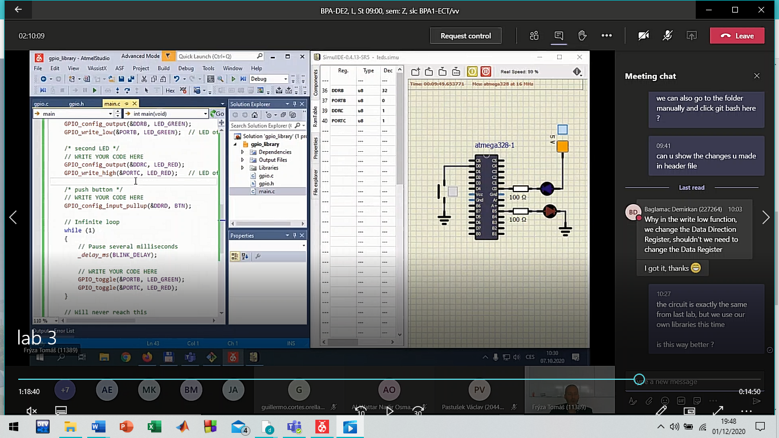

The function declaration serves so that the compiler need the information, basic information for knowing about the variables that needs to use, or where need to save the information.

On the other hand, the function is the place where we write what we want the program do. We write the code and when the function is called, it receives some variables and use them to send back to the place where is the declaration a value.